JCCA Mission
To encourage the use of quality contractors and construction trades partners that positively impact our local community.

JCCA General Membership Minutes May 12, 2021 at 5:00
**Cascades Manor House**

- Call to Order 5:30 pm
- Pledge/Invocation
- Welcome with self-introductions around the room
Pause meeting to eat once done re-opening meeting

- Approve April membership minutes
Motion by Bob Kellogg and seconded by Ryan Berridge to approve minutes as presented. Motion carried.
- President’s Report
Slate of Officers for 2021-2022 Board
Doug Warren, President – Unanimous
Ryan Berridge – VP – Unanimous
Melissa Streoede Treasurer - – Unanimous
Craig Hatch – Secretary - – Unanimous
Mike Hirst – willing to stay on as director (10 votes)
Andy Cook – willing to stay on as director (7 votes)
Donn Roberts – willing to stay on as director (5 votes)
Mike England – interested in director position (13 votes)
Jessica Webb – interested in director position (12 votes)

Votes were cast by ballots – Results are as follows and will serve for 2 years:
Doug Warren, President (2021-2023)
Ryan Berridge – VP (2021-2023)
Melissa Streoede Treasurer (2021-2023)
Craig Hatch – Secretary (2021-2023)
Mike Hirst – willing to stay on as director (2021-2023)
Mike England – interested in director position (2021-2023)
Jessica Webb – interested in director position (2021-2023)

Motion by Craig Hatch and seconded by Jessica Webb to accept the slate of officers as voted on by the membership. Motion carried.

- Treasurers Report- Melissa Stroede
Update on 2020 dues and dinners outstanding
Update on 2021 invoice still outstanding
Square for credit cards

- Education Report- Dan Draper
Highlight the JCCA Scholarship recipients

- Scholarship Committee- Dan Draper
1 - Georgia Fotjesk Scholarship - Andrew Poling (Western HS),
Present along with Georgia
2 - JCCA scholarships named after Marv Swanson - Christopher Howard (Western HS)
Present
3 - JCCA scholarships named after Jamie McKibbin - Cole Sharp (Western HS)
Present
4 – O’Harrow Construction Company Scholarship - Joseph Olkowski (Michigan Center HS)
Present
5 – Christoff & Sons Scholarship – Dylan Krieger (Michigan Center HS)
Present along with Ted
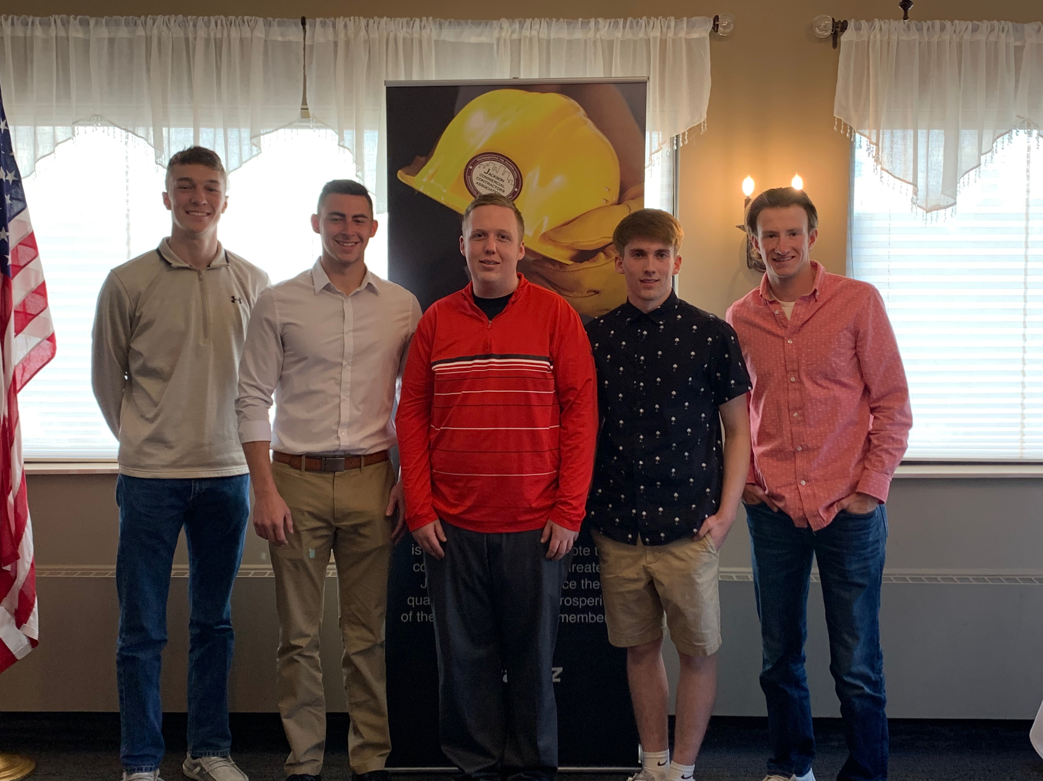

- Marketing Report - Ted Christoff
“Like” the JCCA facebook page www.facebook.com/ThinkJacksonContractorsFirst
“Use the JCCA Forum”
Plan to have a golf team in the August 13th JCCA Golf Outing

- Membership Report/Sponsor Support - Tom Rooney
Dinner Sponsors – Mark Schissler
May Sponsors –
Rehmann (Dave Page, Andrew Rose, Bill Burke),
Willbee Transit Mix Co., (Andrew)
Willis & Jurasek PC (Kyle Luttig)
Willis & Machnik Financial Services (Dan Machnik and Michael England)
343 Technologies LLC (Michael & Sarah Walters)
Pavement Management/ Mullins Asphalt, Wellman Masonry Inc., Yearling Electrical Service LLC, ABC Reproduction Co., ABC Supply Co.

- New Business
Anything to disucss?
- Local Projects Report
Jackson YMCA – Granger Construction - Jeff Havranek jhavranek@grangerconstruction.com

- Membership Drawing – Won in April 2021 by Jeff Landon with Curtis, Curtis Brelinski
Have to wait until pot gets over $250 to being the drawing again

- JCCA Membership Drawing – to be on with Greg O’Connor
343 Technologies

- 50/50 Drawing - $5 for 3 and $10 for 7 tickets
Andy Cook’s Wife ($105)
No membership meetings June, July or August
Next Membership Meeting Sept. 8th at 5:00 pm
Golf Outing – August 13, 2021 at 9:00 am

- Adjourn 7:00 pm

